DON WILSON

I am an experienced Musician, Singer, and Entertainer with a musical history and track record that goes back to the 70’s.

I recently released a song and video "The ballad of Happy Feet" a humorous and intriguing story about the adventurous Emperor penguin who came ashore on the Kapiti coast at Peka Peka last year.
The song received a great response from all over the world, and accumulated over 20,000 you tube hits in less than a few months.
link : http://www.youtube.com/watch?v=0c57ySL07_M

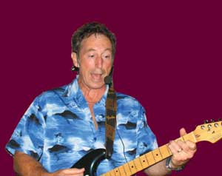
I have been playing as a solo entertainer extensively around the greater Wellington area for a number of years, as well as performing throughout New Zealand, and at times in Australia.

My aim is to always provide an energetic and dynamic performance.
I utilise a powerful state of the art sound system which incorporates the latest ‘wireless’ guitar and microphone technology, which allows me to leave the stage and interact with the audience, involving them with a distinctive blend of humour and entertainment.

A feature of my act which proves very popular is a segment where I sit down at a table of people randomly, and have an acoustic sing-along which inevitably involves taking requests, and engaging in a certain amount of repartee.
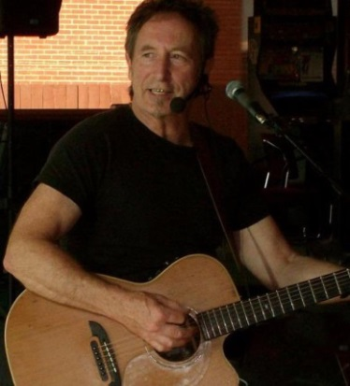
I have a vast repertoire that covers classic hits from the ‘50’s to the present day’ with 60’s, 70’s, 80’s my speciality.
It includes a range of styles from more mellow country flavoured songs featuring acoustic instruments right through to heavy electric rock where the dance-floor is filled, and everyone is rocking.

All the great artists are covered from:
Elvis Presley | The Beatles | The Doors | Coldplay
Chuck Berry | Rolling Stones | Eric Clapton | Robbie Williams
Buddy Holly | Bob Dylan | Bruce Springsteen | Dave Dobbyn
Jerry Lee Lewis | Neil Diamond | Johnny Cash | Dragon
Everly Bros | Queen | Kenny Rogers | Exponents
Roy Orbison | The Eagles | Oasis | Split enz
Van Morrison | Bob Marley | Chilli Peppers | Crowded house
Cat Stevens | Neil Young | Radiohead
There are many more popular artists and songs covered, including my original hits and latest songs.
As well as private, and corporate functions, I play at many bars and clubs in Wellington, Hutt Valley, Wairarapa, and the Kapiti Coast where I reside.
These venues include the Featherston tavern, Backbencher, Four Kings, Petone Workingmans Club, Upper Hutt Cossie Club, Greytown, and Masterton Workingmans Clubs, Monteiths, Lifeboat tavern, Johnsonville club, among many others.
I regularly provide the entertainment for Chris Parkin’s high profile Museum Hotel Christmas function, and have done several functions for Weta’s Jamie Selkirk.
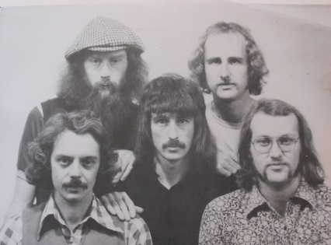
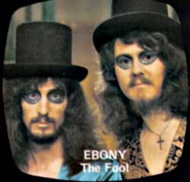
My first major success was as one half of the duo ‘Ebony’, we released several singles and performed well in the “New Faces” and “Studio One” TV programs. Our song Big Norm topped the national sales charts and earned us a gold disc. We also won the NZ Music award for ‘group of the year’ with the song, and received the last telegram to be sent by the Prime Minister Norman Kirk congratulating us on our win.
I then formed the band ‘The Heartbreakers’ which featured ex members of Ebony, Bulldogs All-Star Goodtime Band, and Tambourlaine. We toured extensively throughout New Zealand in the late seventies and had a very popular residency at the Cricketers Arms Tavern in Wellington. We released several singles including Just Like Romeo and Juliet which reached the national top twenty and was number one in Wellington among other places. We won a NZ Music award for our song Computer Man. We made numerous TV appearances on local pop program ‘Ready to Roll’.
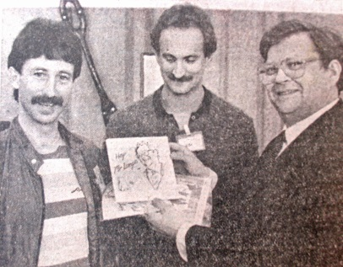
Following the break-up! of the Heartbreakers, the very popular band ‘The Romney Army” was formed in the early 80’s and from this evolved the duo ‘Schreuder and Wilson’. We played extensively around the lower North Island, and released a single Hey Mr Lange in 1985 which received considerable media attention.
We also recorded twenty tracks including the title track for the TV series ‘Peppermint Twist.’ We had a successful residency at the ‘Thank God Its Friday’ bar in Wellington over this period.
I turned solo in the early nineties and was resident entertainer at the Bond St Inn (latterly the Loaded Hog) in Wellington for five years where I built a substantial following.

My first solo album Feel the power featuring all original songs was released in 1996, the album was mixed by award winning engineer/producer Nigel Stone.
I am currently working on a new album of original songs.
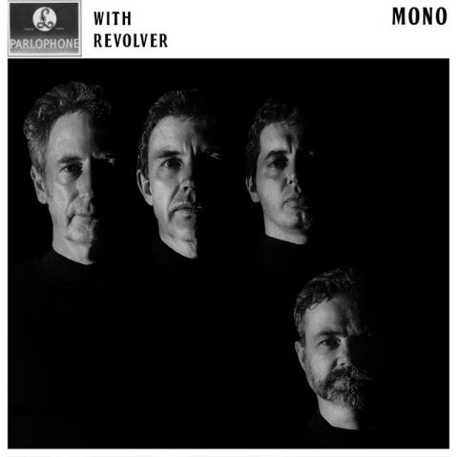
BEATLES tribute Band & Duo

A recent endeavour is the formation of an excellent Beatles tribute act comprising of a 4 piece band "Revolver"
We are also able to play as a more cost efficient duo "Beatles 2" basically a Lennon/ McCartney with ‘George, and Ringo’ on high quality backing tracks.
Both acts feature great attention to detail with authentic instruments, amplifiers, and several costume changes.
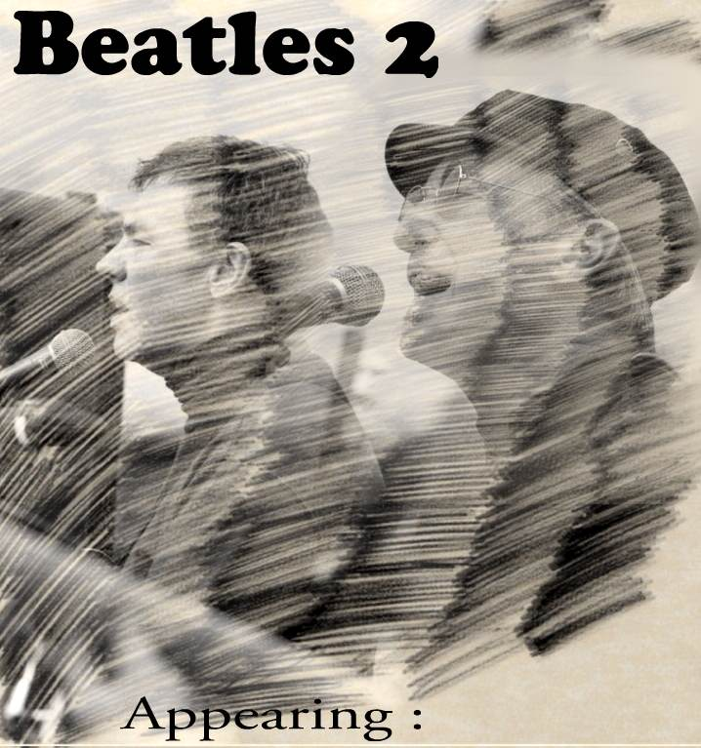
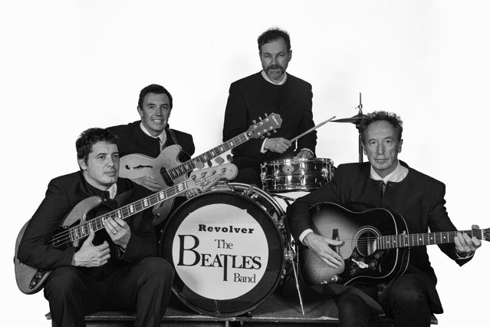
The sound of the world’s greatest and most influential band comes alive with energy and commitment as all members are avid Beatles fans and dedicated to perfecting all aspects of the Beatles music.

